DIGITAL THERMOMETER
Detailed Explanation with Image

Introduction
A digital thermometer is an electronic device used to measure body temperature. It provides fast and accurate readings using electronic sensors instead of mercury.

Working Principle
The thermometer uses a temperature sensor to detect heat. The sensor signal is processed by electronic circuits and displayed digitally.

Main Parts
- Temperature Sensor – Measures temperature
- Signal Conditioning Circuit – Processes sensor signal
- Microcontroller – Converts data to temperature value
- LCD Display – Shows temperature reading
- Battery – Power supply

Digital Thermometer Image
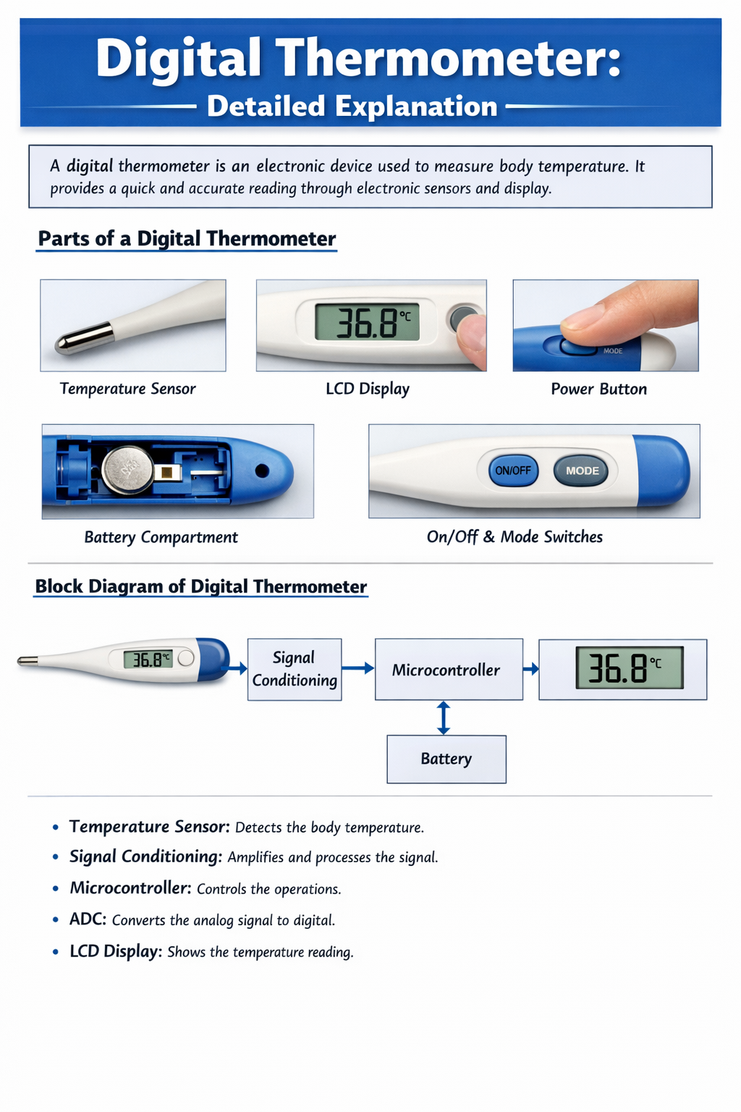

Conclusion
Digital thermometers are safe, accurate, and easy to use. They are widely used in medical, industrial, and household applications.

